> **with (DEtools):**

> **with(plots):**

Warning, the name changecoords has been redefined

> **ecdif1:=diff(y(x),x)=2*x*(1+y(x)^2);**



> **sol1:=dsolve(ecdif1,y(x));**



> **with(plots):**

> **y1:=(x,c)->tan(x^2+2*c);**



> **plot([y1(x,2),y1(x,3),y1(x,4)],x=-1/2..1/2,color=[orange,yellow,green]);**

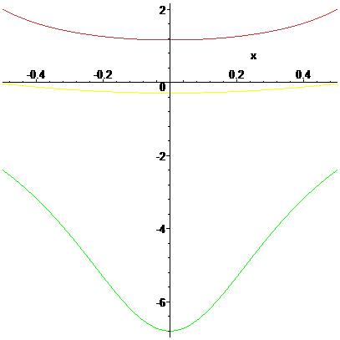

>



> **restart:**

> **with(plots):**

> **with(DEtools):**

> **ecdif2:=diff(y(x),x)=(-2*x*y(x)^2)/(x^2-1);**



> **sol2:=dsolve(ecdif2,y(x));**



> **right_hand_expr:=rhs(sol2);**



> **y2:=unapply(right_hand_expr,x,_C1);**



> **plot([y2(x,2),y2(x,3),y2(x,4)],x=2..5,color=[orange,yellow,green]);**

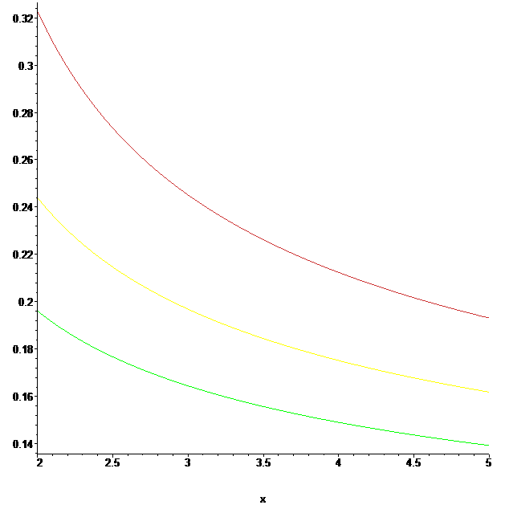

> **restart:**

> **with(DEtools):**

> **with(plots):**

Warning, the name changecoords has been redefined

> **ecdif3:=diff(y(x),x)=(x^2+y(x)^2)/(2*x^2);**



> **sol3:=dsolve(ecdif3,y(x));**

> **right_hand_expr:=rhs(sol3);**





> **y3:=unapply(right_hand_expr,x,_C1);**



> **plot([y3(x,2),y3(x,3),y3(x,4)],x=2..5,color=[orange,yellow,green]);**

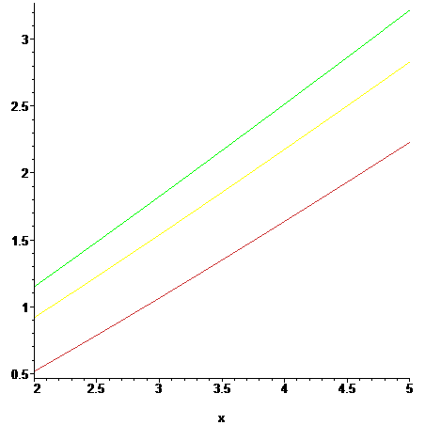

> **restart:**

> **with(DEtools):**

> **with(plots):**

Warning, the name changecoords has been redefined

> **ecdif4:=diff(y(x),x)=-x/y(x);**



> **sol4:=dsolve(ecdif4,y(x));**



> **y41:=(x,c)->sqrt(-x^2+c);**



> **plot([y41(x,2),y41(x,3),y41(x,4)],x=-1..1,color=[orange,yellow,green]);**

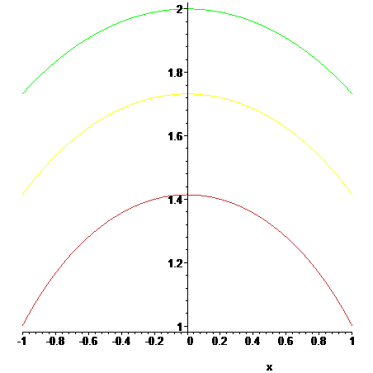

> **y42:=(x,c)->-sqrt(-x^2+c);**



> **plot([y42(x,2),y42(x,3),y42(x,4)],x=-1..1,color=[orange,yellow,green]);**

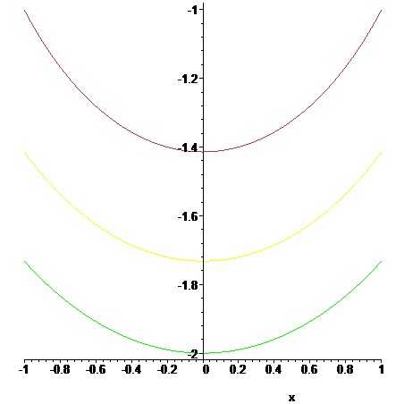

> **restart:**

> **with(DEtools):**

> **with(plots):**

> **ecdif5:=diff(y(x),x)=-x/y(x)^3;**



> **sol5:=dsolve(ecdif5,y(x),implicit);**



> **left_hand_side:=lhs(sol5);**



> **lhs5:=subs(y(x)=y,left_hand_side);**



> **f:=unapply(lhs5,x,y,_C1);**



> **implicitplot([f(x,y,0)=0,f(x,y,0.5)=0,f(x,y,1)=0],x=1..5,y=1..5,numpoints=10000);**

Error, (in plot/iplot2d) invalid 1st argument (the function) {[y^4+2*x^2 = 0, y^4+2*x^2-.5 = 0, y^4+2*x^2-1 = 0]}

> **ecdif6:=diff(y(x),x)=-(x+y(x))/y(x);**



> **sol6:=dsolve(ecdif6,y(x));**



> **left:=lhs(sol6);**



> **lhs6:=subs(y(x)=y,left);**



> **g:=unapply(lhs6,x,y,_C1);**



> **implicitplot([g(x,y,1)=0,g(x,y,2)=0,g(x,y,3)=0],x=1..5,y=1..5,numpoints=10000);**

Error, (in plot/iplot2d) invalid 1st argument (the function) {[-1/2*ln((x^2+y*x+y^2)/x^2)+1/3*3^(1/2)*arctan(1/3*(x+2*y)*3^(1/2)/x)-ln(x)-1 = 0, -1/2*ln((x^2+y*x+y^2)/x^2)+1/3*3^(1/2)*arctan(1/3*(x+2*y)*3^(1/2)/x)-ln(x)-2 = 0, -1/2*ln((x^2+y*x+y^2)/x^2)+1/3*3^(1/2)*arctan(1/3*(x+2*y)*3^(1/2)/x)-ln(x)-3 = 0]}

Error, (in plot/iplot2d) invalid 1st argument (the function) {[-1/2*ln((x^2+y*x+y^2)/x^2)+1/3*3^(1/2)*arctan(1/3*(x+2*y)*3^(1/2)/x)-ln(x)-1 = 0, -1/2*ln((x^2+y*x+y^2)/x^2)+1/3*3^(1/2)*arctan(1/3*(x+2*y)*3^(1/2)/x)-ln(x)-2 = 0, -1/2*ln((x^2+y*x+y^2)/x^2)+1/3*3^(1/2)*arctan(1/3*(x+2*y)*3^(1/2)/x)-ln(x)-3 = 0]}

> **ecdif7:=diff(y(x),x)=(1/cos(x)-y(x)*tan(x));**



> **sol7:=dsolve(ecdif7,y(x));**



> **right:=rhs(sol7);**



> **y7:=unapply(right,x,_C1);**



>



Error, (in plot/iplot2d) invalid 1st argument (the function) {[cos(x)*tan(x) = 0, cos(x)*tan(x)+2*cos(x) = 0, cos(x)*tan(x)+cos(x) = 0]}

>  **plot([y7(x,2),y7(x,3),y7(x,4)],x=-2*Pi..2*Pi);**

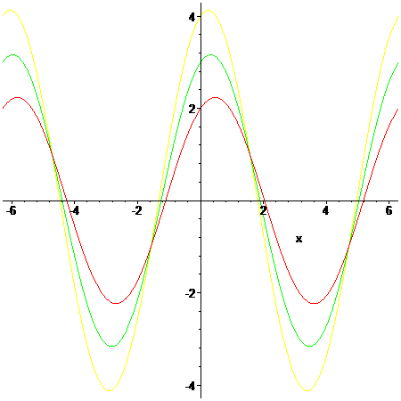

> **ecdif8:=diff(y(x),x)=x^3-2*y(x)/x;**



> **sol8:=dsolve(ecdif8,y(x));**



> **right8:=rhs(sol8);**



> **y8:=unapply(right8,x,_C1);**



> **plot([y8(x,1),y8(x,2),y8(x,3)],x=-1..1);**

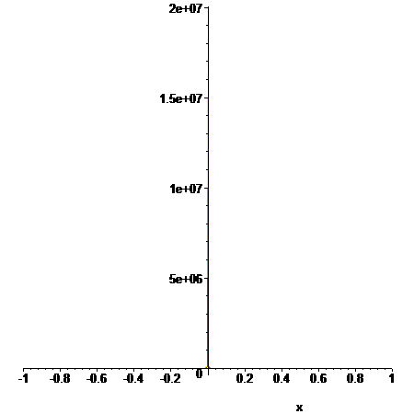

> **ecdif9:=diff(y(x),x$2)+y(x)=sin(x)+cos(x);**



> **sol9:=dsolve(ecdif9,y(x));**



> **right9:=rhs(sol9);**



> **y9:=unapply(right,x,_C1,_C2);**



>  **plot([y9(x,0,0),y9(x,-1,1),y9(x,1,-1)],x=-1..2,color=[black,blue,red]);**

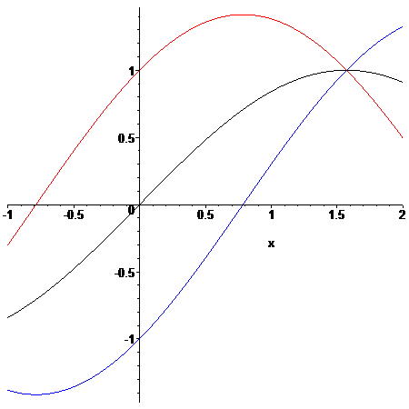

> **ecdif10:=diff(y(x),x$2)-y(x)=exp(2*x);**



> **sol10:=dsolve(ecdif10,y(x));**



> **right10:=rhs(sol10);**



> **y10:=unapply(right,x,_C1,_C2);**



>  **plot([y10(x,0,0),y10(x,-1,1),y10(x,1,-1)],x=-1..2,color=[black,blue,red]);**



> **ecdif11:=diff(y(x),x$2)+4*y(x)=1/cos(2*x);**



> **sol11:=dsolve(ecdif11,y(x));**



> **right11:=rhs(sol11);**



> **y11:=unapply(right11,x,_C1,_C2);**



>  **plot([y11(x,0,0),y11(x,-1,1),y11(x,1,-1)],x=-1..2,color=[black,blue,red]);**

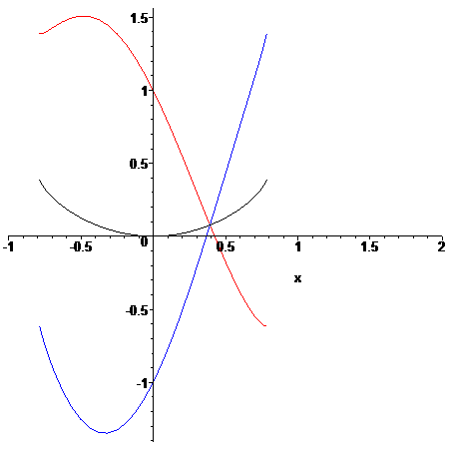

> **ecdif12:=diff(y(x),x$2)-diff(y(x),x)=1/(1+exp(x));**



> **sol12:=dsolve(ecdif12,y(x));**



> **right12:=rhs(sol12);**



> **y12:=unapply(right12,x,_C1,_C2);**



>  **plot([y12(x,0,0),y12(x,-1,1),y12(x,1,-1)],x=-1..2,color=[black,blue,red]);**

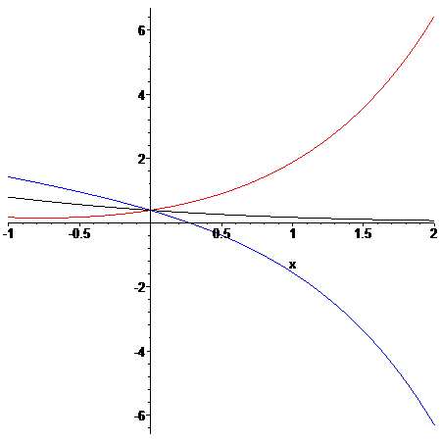

> **restart:**

> **with(DEtools):**

> **ecdif1:=diff(y(x),x)=1+y(x)^2;**



> **cond_in:=y(0)=1;**



> **sol1:=dsolve({ecdif1,cond_in},y(x));**



> **y1:=unapply(rhs(sol1),x);**



> **with(plots):**

Warning, the name changecoords has been redefined

> **plot(y1(x),x=-2*Pi..2*Pi);**



